**Scenario:**

* **Task: Conduct 3 different tests with 1 being recorded across 3 applications, document the actual results within & track any bugs and defects found in Jira.**
* Tests I have decided to execute:

**Smoke Testing** - Initial test to make sure major functionalities are working, and checking for major breakdowns in the application.

**Integration Testing -** Checking that all the modules are combined and working successfully.

**System Testing** - End to End testing, testing the application for its compliance to functional and non-functional tests.

**Recap of Clients and Test Results:**

Client 1: **TravelGuzs** is a Travel Application implementation project.

Application Website - [www.travelguzs.com](http://www.travelguzs.com)

1. **Which Test are you going to run for this application & why?** – System Testing
   1. I will perform *System Testing* on the TravelGuzs application because TravelGuzs is a completed website with many different functionalities that work together for the cohesion of the application.
2. **Conduct Testing & document your actual results within your Test cases.**

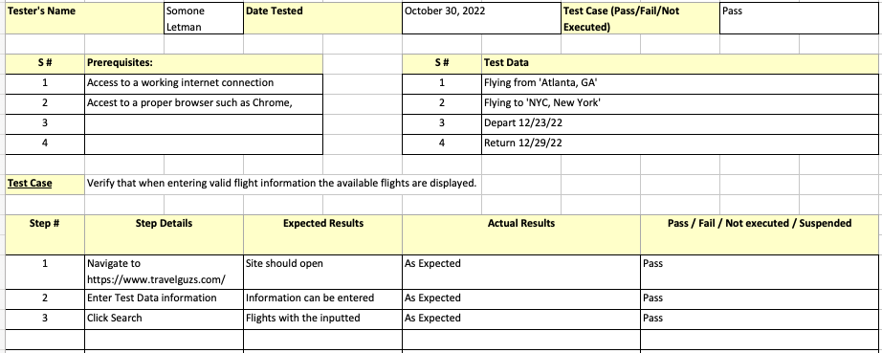

1. **Track bugs/defects in Jira & provide a screenshot.**
   1. No bugs or defects were detected during testing at this time.

Client 2: **BlazeElectronics** is a Tech Electronics Implementation project.

Application Website- [STORE (demoblaze.com)](https://www.demoblaze.com/)

1. **Which Test are you going to run for this application & why?** – Smoke Testing
   1. I will perform *Smoke Testing* on BlazeElectronics because this application is not quite complete. Because of some missing functionality, this disallows the users to continue using the application in its entirety. One missing functionality causes another missing functionality. Major flaws halt further tests.
2. **Conduct Testing & document your actual results within your Test cases.**

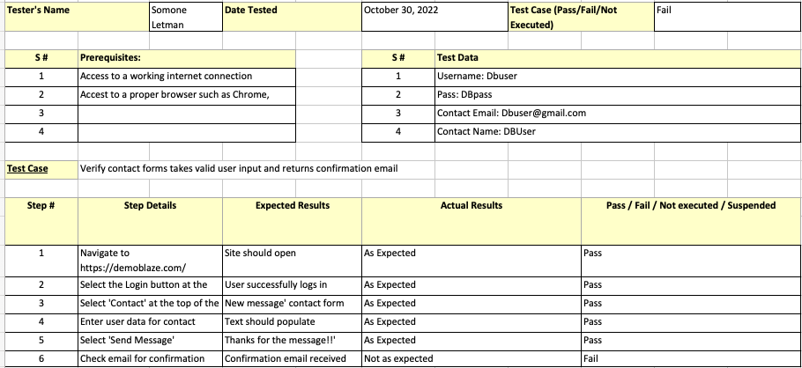

1. **Track bugs/defects in Jira & provide a screenshot.**

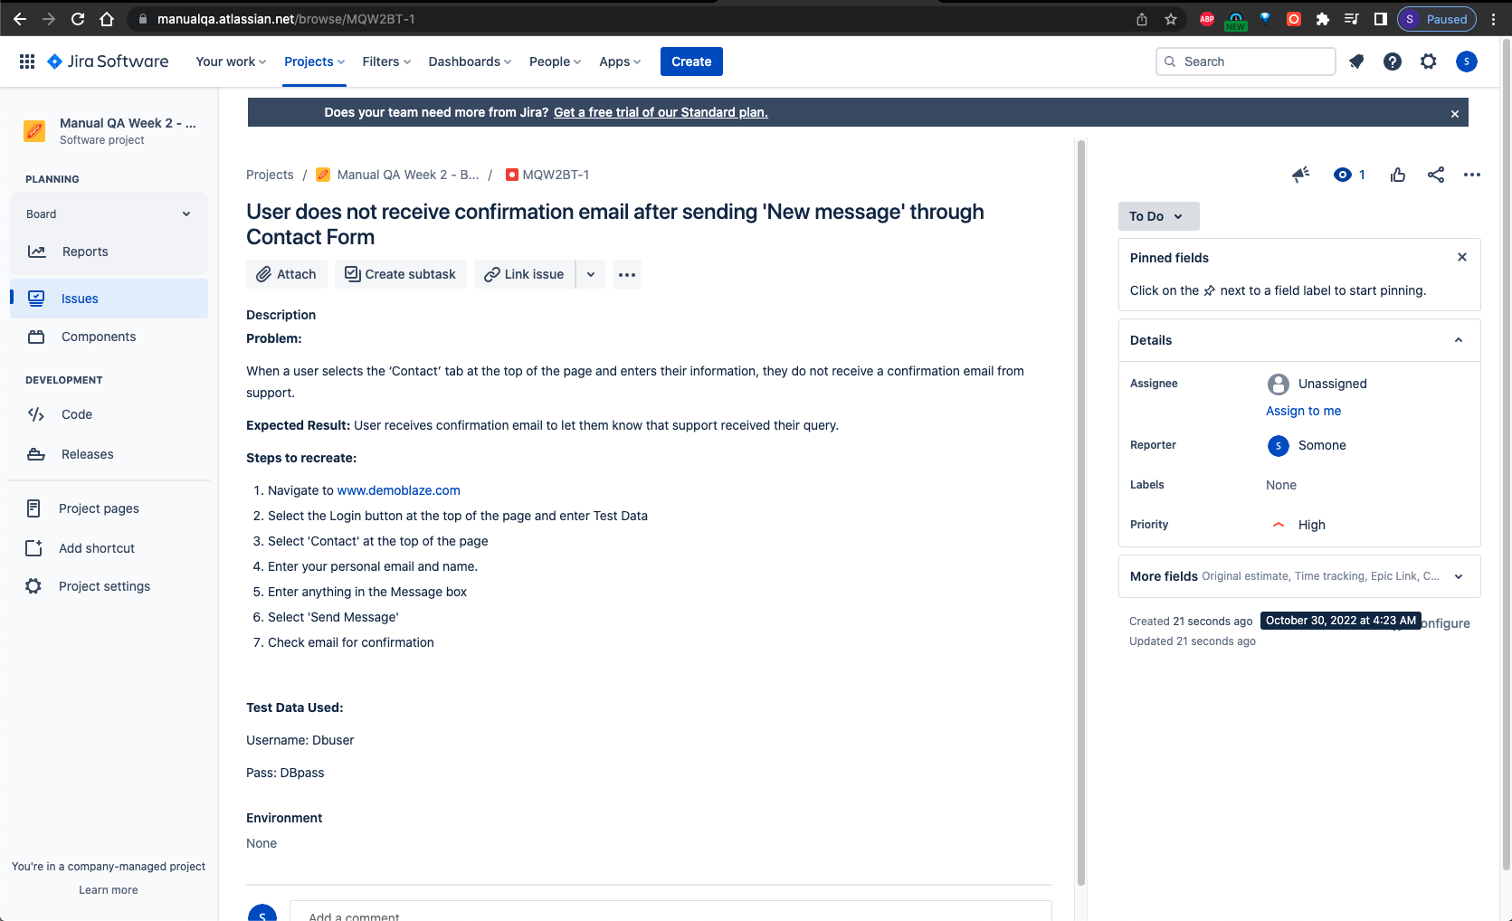

Client 3: **Budget Bestie Salesforce Application** – No link is needed as this is an internal application

1. **Which Test are you going to run for this application & why?** - Integration Testing
   1. I will be using *Integration Testing* because most of the features of my Budget Bestie app work in sync as a combined set of components. Because the components in the unit are complete, the process should execute.
2. **Conduct Testing & document your actual results within your Test cases**.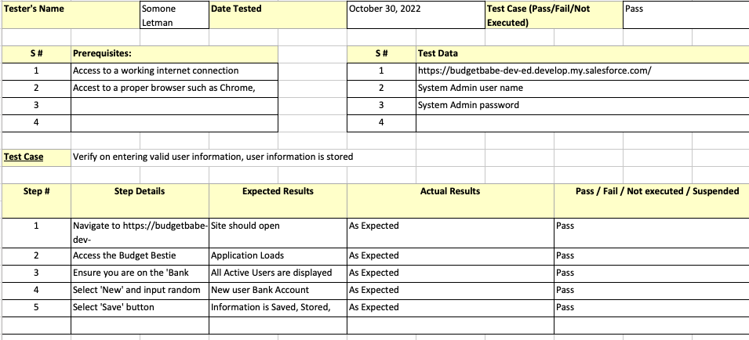
3. **Screen record your live testing & attach it to your submission.**
   1. Video attached.
4. **Track bugs/defects in Jira & provide a screenshot.**
   1. No bugs or defects were detected during testing at this time.